**From:** Thiam Kiat, Goh   
**Sent:** Thursday, October 30, 2014 12:13 PM  
**To:** Caliwliw, Ferdinand; Reyes, Joyce Genette; Che, Matthew; [support.sin-nsc@dbschenker.com](mailto:support.sin-nsc@dbschenker.com)  
**Cc:** Laurent, Kek; Quek, Roger  
**Subject:** RE: MVT GR report (GSD #2100099)

Hi Ferdi,

We will always apply charge code in the Problem Definition (as indicated) whenever the unit failed VMI conditions.

We need these charge code and the warranty status to be in this report so that we are able to run the report in a screen.

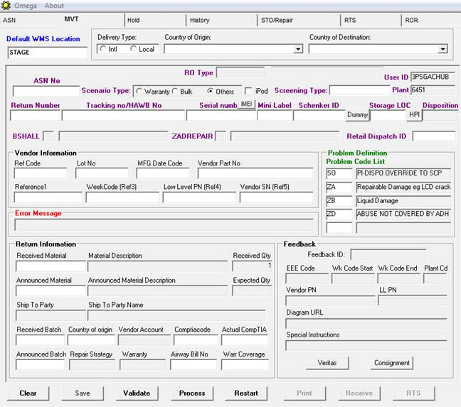

**Goh Thiam Kiat**

Operation Executive

Contract Logistics/SCM, Operations

Schenker Singapore (Pte) Ltd

35 Greenwich Drive, #05-01/02

Singapore 533952

DID:       +65 6713 5937

Mobile: +65 8123 2068

Global website [www.dbschenker.com](http://www.dbschenker.com/)